NEW PATIENT HEALTH QUESTIONNAIRE
Surname:
First Names:
Date of Birth:

PAST MEDICAL HISTORY
Do you have any of the following? If so, you will be offered an Annual Assessment/Medication Review as appropriate. (Please circle as appropriate)
Diabetes | Yes | No
Asthma | Yes | No
Thyroid Disorder | Yes | No
Stroke | Yes | No
COPD | Yes | No
Heart Disease | Yes | No
Epilepsy | Yes | No
Other (please specify)

MEDICATIONS
Please list your repeat medication (continue on separate sheet if necessary)

ALLERGIES
Are you allergic to any substances, including foods or medication?

3

FAMILY HISTORY
Are there any serious diseases that affect your parents, brothers or sisters?
Please circle all that apply and state family member:
Cancer (specify type) | Yes | No | Who/Type
Heart Attack under age of 60 | Yes | No | Who
Stroke | Yes | No | Who
Diabetes | Yes  Type 1 or 2 | No | Who
Thyroid Disorder | Yes | No | Who
Osteoporosis | Yes | No | Who
High Blood Pressure | Yes | No | Who
Asthma | Yes | No | Who
COPD | Yes | No | Who

ANYONE WITH A CERVIX
Please circle as appropriate
When was your last cervical smear test (age 25 - 64)? | Date:
Was your smear test normal? | Yes No
Do you wish to see a Doctor in this Practice for contraceptive services (including the pill, coil or cap)? | Yes No
Number of births and age of children

When was your last mammogram (age over 50)? | Date:

4

GENERAL HEALTH
ALCOHOL (Please Tick Relevant Statement)
Please see table for Units of Alcohol
Questions
I do not drink any alcohol

I drink alcohol within the weekly limits of 14 units for a woman or
21 units for a man

I drink alcohol exceeding the weekly limits of 14 units for a woman or 21units for a man

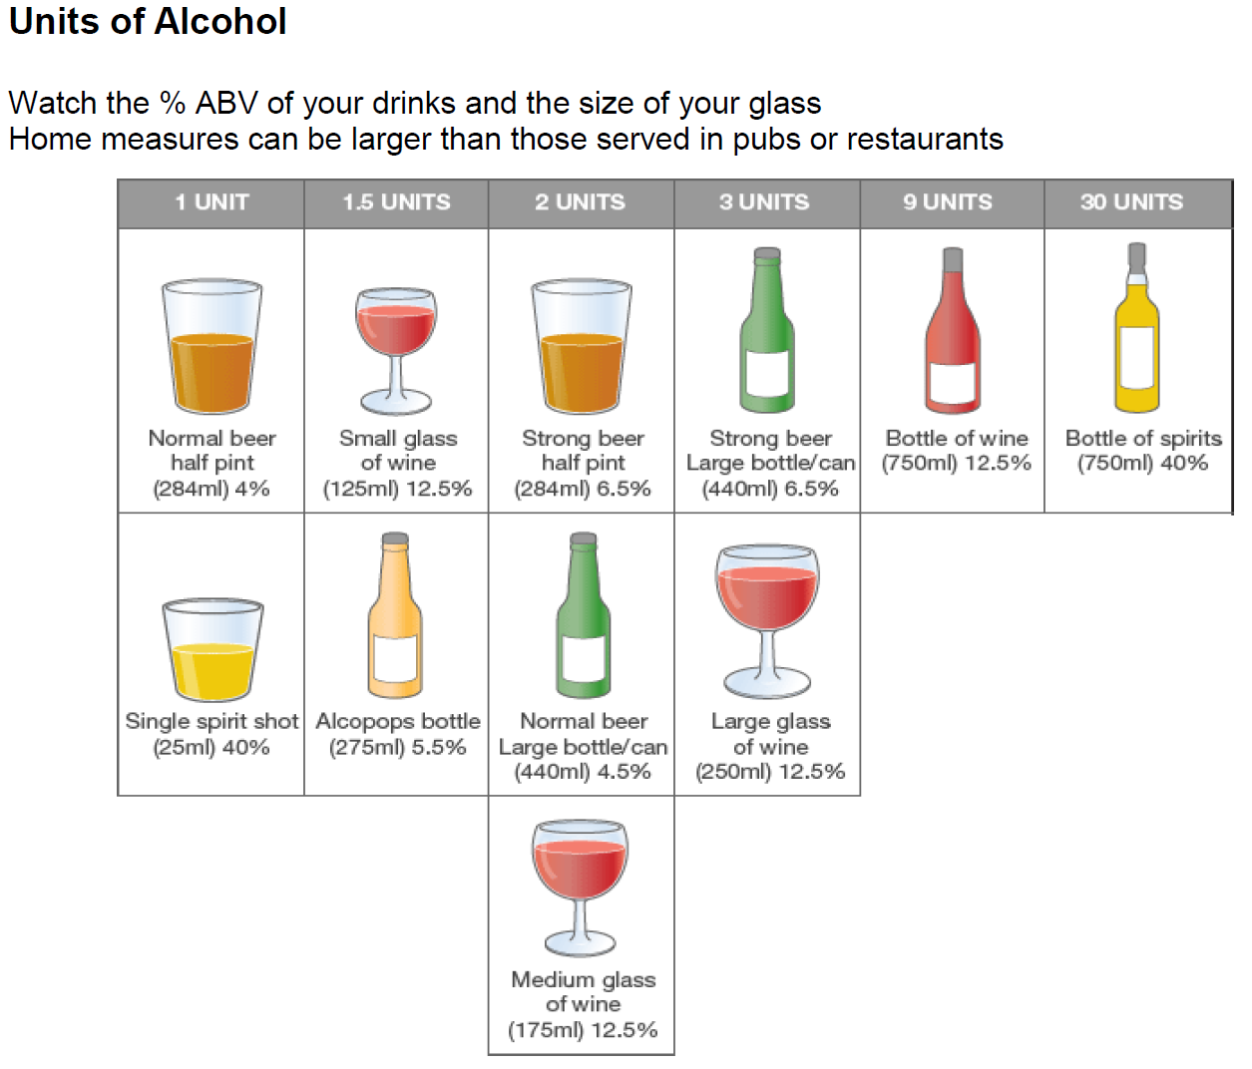

5

GENERAL HEALTH (CONTINUED)
SMOKING
Do you smoke? | Yes | No | Never Smoked
How many per day?
E-Cigarette | Yes | No

GENERAL INFORMATION

DO YOU NEED AN INTREPRETER? (Please Circle)
Arabic | Hindu | Urdu | Bengali/Sytheti
Polish | Farsi | French | Portuguese
Guajarati | Punjabi | Other? Specify:

NATIONALITY (Please Circle)
White Scottish | English | Welsh
Northern Irish | White British | White Irish
Gypsy/Romany | Polish | Other White Ethnic Group
Other Ethnic Mixed Origin | Pakistani | Indian
Bangladeshi | Chinese | Other Asian Ethnic Group
Black African | Black Caribbean | Black British
Black Other Non-Mixed Origin | Other Ethnic Group

ARE YOU HOUSEBOUND?
Yes | No

6

LOOKING AFTER A FAMILY MEMBER
Please circle as appropriate
Are you looking after someone?  Let us know if you are looking after someone who is ill, frail, disabled or has mental health and/or emotional support needs, or substance misuse problems | Yes No
Is someone looking after you?  Let us know if a family member, friend or neighbour looks after you. If yes, they are your carer. You are welcome to invite your carer to accompany you to visits at the Practice | Yes No
Carer’s Name: | Relationship to you:
Telephone Number of Carer: | Is your Carer registered at this Practice?  Yes No Not Known
Address of Carer: | Postcode:

7

COMMUNICATION CONSENT FOR SMS AND EMAIL

With your consent, we can use the above services to notify you of:
- Appointment reminders of your booked appointment
- National issues and events such as flu pandemics
- Results from tests
- The Practice being closed due to unforeseen circumstances
- Cancelled clinics
- Other notifications the Practice deems necessary to your healthcare provision

Your telephone number and email address will only be used by the Practice, and we may use it in referral letters/forms so that the secondary care provider (usually the Hospital) can contact you. We will not pass your information to any other parties.
Care will be taken to ensure that no personal information is released using this service and the Practice will continue to observe the strictest controls with regard to holding personal information in confidence.
You can change your mind at any time if you would like to opt out of the above services by letting us know.

Consent to: | Signature:
SMS Messaging
Mobile Telephone Number:

Email Communication
Email Address:

8

PRESCRIPTIONS
Please refer to the Prescription Leaflet in the Registration Pack for more information. Prescriptions are normally processed within 2 working days. Prescriptions may be delayed if special request authorisation is required. There are various ways to order a repeat medication:
Sign up to the Patient Services – if you wish to use this service, a Sign Up Form is included in the Registration Pack, please complete and hand in to the Practice. Please note that proof of identity is required.
Via a Preferred Pharmacy – ask your local Pharmacy about ordering your repeat prescriptions for you.
Your prescriptions will be sent to a nominated Pharmacy, please circle which one you would like your prescriptions to go to:
Ladywell Pharmacy | Boots Almondvale Centre
Deans Pharmacy | Morrisons Dedridge
Lloyds Howden

POWER OF ATTORNEY
If you have a Power of Attorney, please inform the Practice and provide a copy of the signed and completed document from the Office of the Public Guardian. The copy will be placed in your medical records.
PATIENT PARTICIPATION GROUP (PPG)
The Practice is committed to improving the services we provide to our patients.
- To do this, it is vital that we hear from people about their experiences, views and ideas for making services better
- By expressing your interest, you will be helping us to plan ways of involving patients that suit you will also mean we can keep you informed of opportunities to give your view and up to date with developments within the Practice
- If you are interested in getting involved in the PPG, please circle yes in the box below and we will arrange for the Practice to make contact with you.

Please circle as appropriate

Yes I am interested | No I am not interested at this time
Name:
Date of Birth:
Contact No:

9

SHARING PATIENT RECORD CONSENT FORM
Electronic records are kept in all places where you receive healthcare. These places can usually only share information from your records by letter, email, fax or telephone. At times, this can slow down your treatment and mean information is hard to access.
You can choose to share your electronic record with other care services or you can choose not to share your electronic record with other care services.

Patient/Representative Signature:
Representative Name:
Relationship to Patient:
Date:

10

HOWDEN HEALTH CENTRE

Howden Road West, Livingston. West Lothian EH54 6TP

Telephone: 01506 423800
About Patient Services

We offer an online service known as Patient Services. This service is linked to your medical record and allows you to see a comprehensive list of all your current REPEAT medication and is available for you to view and select required items. A free text box is available should you wish to order non listed items that you have been prescribed in the past or items that you are not able to tick to request (please note that prescriptions may be delayed if special request authorisation is required). This free text box is only activated if you have selected at least one repeat medication. If you do not have medication on repeat you would need to request your medication through other routes (Pharmacy, in person or in writing). The service is available 24 hours a day and allows you to monitor the processing of your medicine request in real time. This will allow you to interact with our Practice in relation to requesting your repeat medication using the Internet at your convenience, even when we are closed.

To sign up for this service, please complete the Registration Form overleaf and provide a valid form of identification. Once registered, details of your registration account will be posted to you within 7 working days of receipt of your Registration Form. If you have not received this within the 7 working days, please contact the Practice. For newly registered patients this may take longer. Once you have received this information, please follow the instructions to complete the online registration process – please note this must be done within the timescale given as the registration will expire.

Some older children may wish to sign up for this service. Legally, patients 12 years and over may provide their own details and are required to sign the Registration Form.

The Patient Services website has a facility to check appointments. Please note that although a specified time is allocated to telephone consultations, the actual time of the call will not be as specified. The call will be either AM (morning) or PM (afternoon).

11

Patient Services - Registration Form
If you would like to register for this online service please complete the form below and return it to your practice in person, along with a valid form of identification.
Once you are registered the practice will give you the information that will enable you to create a username and password, this would be within 7 working days of receipt of your form unless you are a newly registered patient when this may take longer.
Patient details | Please complete in BLOCK CAPITALS
Patient forename
Patient surname
Date of birth |  |  | / |  |  | /
Email address
Mobile number
I consent to this mobile number being used by the Practice to send notifications and reminders | Yes No
Signature
Date |  |  | / |  |  | /
Completing the form on behalf of the patient?
Print forename
Print surname
Relationship to patient
Signature
Date |  |  | / |  |  | /

Staff use only
Patient ID seen |  |  |  |  |  |  |  |  | Staff Initials Date:
Type of ID
SMS Coded |  |  |  |  |  |  |  |  | Staff Initials
Confirmation Sent |  |  |  |  |  |  |  |  | Staff Initials
Date All Completed |  |  | / |  |  | /

12

PRACTICE LEAFLETS
There is an abundance of information contained in our Practice Leaflets.
Please find attached:
- Prescription Leaflet
- National Screening Programmes Leaflet
- GP Advanced Physiotherapy Practitioner Service (GPAPP) Leaflet
- Mental Health Service Leaflet
- NHS Pharmacy First Plus Leaflet
- Test Results Leaflet

13

